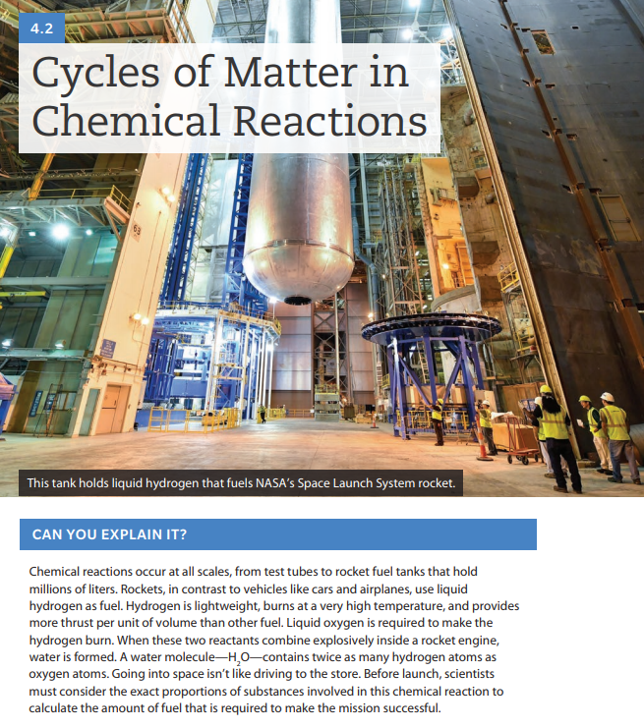

In your notebook, title the next page “Micro Rockets Experiment”, put a star for investigation and today’s date, then answer the following questions in your notebook:

1. Make a prediction—what proportion of hydrogen and oxygen gas would make the best fuel? Explain your prediction.

Tomorrow in class we will be making and testing mini-rockets out of pipet bulbs, as shown below. You will be testing different ratios of hydrogen and oxygen, then launching them to determine what makes the best rocket.

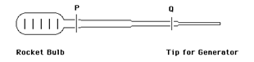

1. What kind of data could you collect to see what ratio is best?
2. What kind of things will need to be held constant to get accurate data?
3. The pipet bulb is divided into 6 equal sections. What are all the different ratios of hydrogen to oxygen you could try?

Once you have finished answering the questions above, watch the following video:

[Rocket Setup Video: https://edpuzzle.com/media/5cb8eb50f54d98409a7ef871](https://edpuzzle.com/media/5cb8eb50f54d98409a7ef871)

After watching the video, outline a procedure for testing your micro rockets.

**You will not be allowed to do the lab if you have not completed the pre-lab. No exceptions.**